Completing the Events at the Border (E@B) form

**Version 1.0**

**Author – Mark Goldsack,**

**BF National Intelligence Hub,**

**COP – Central Operations Platform - Events at the Border Product Owner**

**All the content of this guidance is classified as Official Sensitive.**

# Contents

Contents………………………………………………………………………………………2

About this Guidance…………………………………………………………………………3

Contacts………………………………………………………………………………………3

Changes to the last version of this guidance……………………………………………..3

When to complete an Event at the Border Form…………………………………………4

How to complete an Event at the Border Form…………………………………………..5

Can I obtain a PDF copy of an Event Form?........………………………………………10

Handling Code. Can it be shared? .............................................................................10

What BFNIH officers will do? .....................................................................................11

How to propose changes to Events at the Border Forms?.........................................12

Notification Requirements - Control Strategy Thresholds…………………………….. 13

Record Clandestine/ Migrant/ Immigration/ Facilitation Events………………………..19

Record Concealments detections…………………………………………………………20

Record Immigration Case Events…………………………………………………………21

Record Cash Events………………………………………………………………………..22

Record National Security Referral/ Person/ Items……………………………………….23

Record SAMS (Safeguarding & Modern Slavery Event)………………………………..25

How to Upload documents/ images and photos…………………………………………26

# 

# About this guidance

This guidance explains when and how a frontline Border Force officer must complete an Event at the Border (E@B) form in order to inform Border Force Intelligence Directorate and commodity leads about an event at the UK border.

An event is a detection or interception (such as smuggling of P&R goods, suspected human trafficking/ immigration crime etc), Cash Detection and a National Security Referral. The Event form gives Intelligence officers a chance to gather information on the event immediately.

The Form holds more details than IEN (Immediate Event Notification) as it is a combination of 3 existing forms, IEN, Cash Detection and National Security referral. So currently, in an event where you have Cash, it is CT related and above IEN thresholds, under current guidelines, all three forms are required so you would have to triplicate your data input, this is very time consuming. Depending on data available, an Event at the Border form should take approximately 11-12 minutes.

## Contacts

If you have any questions about the guidance and your line manager or senior caseworker cannot help you or you think that the guidance has factual errors, then email:

Border Force National Intelligence Hub at [BFNIH@homeoffice.gov.uk](mailto:BFNIH@homeoffice.gov.uk)

Product Owner, Mark Goldsack, [mark.goldsack@homeoffice.gov.uk](mailto:mark.goldsack@homeoffice.gov.uk)

BF Intelligence Change Team at [BFIDChangeTeam@homeoffice.gov.uk](mailto:BFIDChangeTeam@homeoffice.gov.uk)

If you notice any formatting errors in this guidance (broken links, spelling mistakes, missing reference data etc) or have any comments about the layout or navigability of the guidance then you can report these errors to COP (Central Operations Platform) by raising an issue using the following link:

<https://support.cop.homeoffice.gov.uk/servicedesk/customer/portal/3>

* version **1.0**
* published for Home Office staff on **24th** **July 2020**

## Changes from last version of this guidance

This is new Guidance. The Control Strategy priorities can be found in this new guidance alongside the thresholds set for items and people detections that the COP system uses to send notifications to the correct recipient, whether to BFNIH/ National Security/ Cash Leads and BF Safeguarding. This is a significant change from IEN Guidance as the officer had to ascertain whether IEN was applicable to a detection. With COP Events at the Border workflow, the system calculates this for the user. By recording ALL detections regardless of amount, more data will be readily available for Intelligence Analysts/ Intelligence & Targeting staff which will provide better quality data to inform future targets.

The form is intuitive and agile, COP are able to make changes quickly. COP are also investigating links to other BF systems such as ePMS/ SIP/ Atlas.

When to complete an Event at the Border Form

The Events at the Border form is to be completed for **ALL** detections or positive outcomes made at the UK border, whether items or people events. Any existing local reporting procedures should continue to be followed dependant on what has been encountered or detected. The COP system has a workflow where it compares the data you provide against existing Control Strategy thresholds and pushes your detection details to the relevant department, depending on the answers you have provided within the Form. See below graphic which outlines the notification workflow:

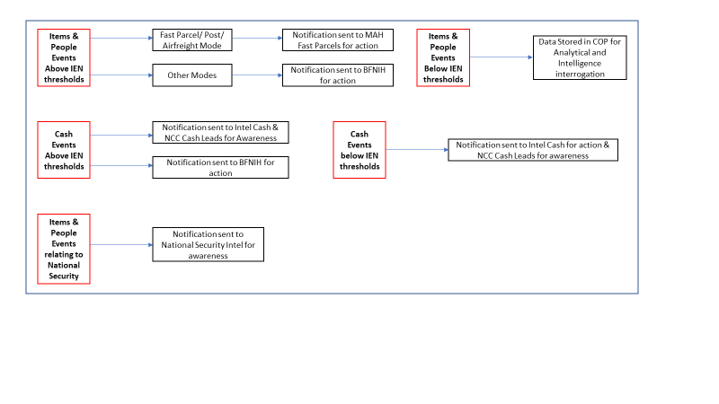As per IEN guidance, you must submit the Event at the Border Form within 2 hours of the event and no later than the end of your shift.

For current COP Control strategy Thresholds, please see Notification requirements for more information.

# 

# How to complete an Event at the Border Form

The Event at the Border (E@B) form can be accessed through the [Central Operations Platform (COP).](https://sso.digital.homeoffice.gov.uk/auth/realms/cop-prod/protocol/openid-connect/auth?client_id=www&redirect_uri=https%253A%252F%252Fwww.cop.homeoffice.gov.uk%252F&state=43d0dbca-8001-4f5f-a84a-f819c043f75a&response_mode=fragment&response_type=code&scope=openid&nonce=5bf4b5b9-1e69-4ae5-9982-6312178eca4d) The form is located in:

Dashboard - Forms and under **“RECORD BORDER EVENT.”**

Within COP, users can find guidance on **COP Training/ Product Page**.

Users are instructed to complete the form as fully as possible, although this may seem time consuming, the details you input will provide Intelligence/ Targeting with more meaningful information, inform better debriefs and improve future targets. Additionally, Events will link into other BF systems, therefore reducing the need to double-key.

There are mandatory fields indicated by * (an Asterix). Other boxes are free-text boxes and drop-down options, which has a type ahead option. The completing officer must include as much relevant detail as possible. The form contains the following fields:

* **Reference Number** –
  + This is provided at the start of the form – prefixed COP. You will need this reference if you wish to take a PDF after completion.
* **Detection/ Passenger Self Declaration** –
  + Detection is for **ALL** positive events involving Items and People.
  + **Negative Outcome is not Live yet.**
* **COVID-19 related detection**.
  + Choose this if detection relates to CV-19 activity/ items/ person stop relates to CV-19, such as counterfeit masks etc or work is linked to Op Greenhill and other Cv-19 Ops.
* **Interception Details** – **was it targeted?**
  + **Following Intel** - INPUT INTEL REFERENCE.
  + **Targeted by Targeting Hub,** INPUT REFERENCE & WHAT CATEGORY.
  + Post Arrival – Visual Selection
  + **SABR** – (STRUCTURED ASSESSMENT OF BORDER RISK), Please INPUT REFERENCE
* **Mode of Transport** –
  + Choose the mode you are working in.
  + Freight/ Tourist juxtaposed controls in Channel Tunnel, choose RoRo Freight/ RoRo Tourist. Eurostar controls use Rail Passenger.
  + There is capability later in the form to choose more than one mode, so Fast Parcel/ Airfreight loads in a RoRo vehicle can be recorded more accurately.
  + Terminals & sub-locations, this isn’t mandatory and if you find your area is missing, please make COP aware.
* **IMMIGRATION EVENT** –
  + Choose **Yes** to record detections of people including Clandestines/ migrant activity/ facilitation etc. You will be asked Number and Nationality later in the form.
  + If you have documents, you can add this as an additional person and choose their role, illegal in UK/ Clandestine/ Refused Leave to Enter etc
  + If you don’t, choose the Large Immigration Event option to record Nationality and number.
* **Do you have person details etc**? –
  + Choose **YES** if this is an accompanied movement (RoRo/ Air & Rail Passenger/ GA/ GM/ Commercial Maritime). You will be asked driver/ passenger/ person details later in the form.
  + Choose **No** for Migrant Events (if pilot/ facilitator not identified)
  + Choose **No** for Unaccompanied (Container/ RoRo, Railfreight/ Airfreight/ Fast Parcel & Post modes)
* **Were any items Seized** **or declared? –**
  + Cash – choose this if cash or AVTC – **Click this option even if Cash is returned**
  + Firearms
  + Other items – This covers all other items that might be detected, drugs/ cigarettes/ alcohol/ documents/ empty concealments
* **Seizure Notice** –
  + Click Yes if it has been issued
  + **(If Freight/ Container) - Revenue Fraud Detection** – Click yes is relevant and answer subsidiary questions on seizure of load/ container. What Reference?
  + **Centaur/ ePMS Number** – if you have this at this stage, please enter it. People Events, please input relevant CID/ Atlas reference.
* **Control Strategy** –
  + Please choose the relevant Control Strategy for the detection.
  + If Cash/ Immigration Crime, user has capability to record the relevant theme, for example:
    1. Control Strategy - Modern Slavery Human Trafficking, Select relevant theme – such as Servitude.
  + *By choosing some Control Strategy Options, you will be asked additional questions. MSHT – you will be asked to complete a SAMS Panel later in the form regarding the subject.*
* **Operations/ Exercises** –
  + If it relates to an Operation, please input the Operation Name.
* **Selection indicators** –
  + These are specific, separately identified criteria which, together or individually, are a tool to identify non-compliance - users can add as many Selection indicators that are necessary - the selection indicators are relevant to the transport method and come from existing lists of indicators in IEN/ Cash form and National Security referral.
  + If targeted by targeting Hub, please ensure indicators from target sheet/ alert are transferred to the Event form.
  + If visual, choose the relevant indicators
  + For Passenger/ National Security and selected due to behaviour, choose the relevant behavioural indicator.
  + Free-text, use this to add more context to the selection. **DO NOT INPUT RANDOM STOP**
  + If it was a referral from another Agency, use the relevant indicator (this includes Agency Search Units such as Wagtail Dog Unit or Airport/ Port Security etc)
* **Record the Agency involved**,
  + If Referred to/ referred from/ adopted by/ unadopted. This is asked later in the form. Select relevant Agency detail. **IF Adopted CASH, Choose No** as Adopting Agency is asked in Cash Page
* **Officer involved** –
  + record all officers relevant to this detection and ensure that **LEAD** officer is identified.
* **File Upload** –
  + capability to upload images/ documents.
  + **Awaiting guidance on evidence and disclosure. Any upload is time/ date stamped and by who.**
  + Document upload can be used for photos of imposter docs/ forgeries/ Clandestine location proformas etc.
  + Documents that can be uploaded are listed within the form.

**The above sections impact the Cover form and are generic questions for all modes. The next sections are Modal/ Detection specific questions.**

* **PERSON FORM**

*if accompanied and Yes answered to Person details for Driver/ Passenger/ facilitator.*

* + Complete person form including **Identity**/ **Visa**/ **Address**
  + What Role? Where they searched? Detection technology used? Illegal in UK?
  + Referred to CT Police? **If yes, this will push the Events form to National Security Intel.**
  + **Subject of MSHT/ CSAE? Complete if relevant**
  + **Concealed?** Complete if relevant. Subject found in boot of a car/ Cab of freight vehicle etc.
  + **Identity –** complete details if you have Passport/ ID Card. If not, complete what they claim to be, estimate DOB.
  + **Visa Details –** Complete if relevant to the movement, do they need one? Do they have one?
  + **Address –** Complete details if relevant to the detection/ referral to CT Police/ SAMS etc.
* **ITEMS**
* **Complete your item details, category/ details/ quantity/ unit/ brand (if Cigarettes/ HRT)**
  + Detection Technology – listed types of detection technology used
  + Search Performed – listed types of search techniques
  + For Adaptions – Choose Yes – CEMA S88.
    1. If Adapted, choose item category, Vehicle/ Machines used to Transport Goods/ People
    2. Choose relevant Item Details – example Car
    3. Quantity – add correct Number
    4. Unit – item
    5. Seized/ Detained/ Neither – If adaption found on a vehicle to BF and BF are not seizing it, choose NEITHER.
    6. Use Free-text to put more context on the detection
  + Item Concealed – Yes – listed concealment methods (anything missing, please report to COP)
  + Seized/ Detained or Neither. Choose which is relevant for this item.
    1. Seized/ Detained – User is asked for Seal numbers. This is not mandatory; the question is asked as future development is to link Events at the Border (E@B) to ePMS.
  + **Referred to CT Policing**? Literature etc – Yes or No. Complete as applicable. User will receive a separate task (in Own Tasks) to record outcome of National Security Referral.
* **Detection Technology Used** –
  + User is to indicate if detection technology used, the outcome of the technology used, for example input “positive scan image.”
* **Method of Concealment** –
  + User can add as many options as necessary for indicating how the detected goods/ people were concealed - user can also add in additional information regarding access to any concealment in the free-text boxes.
* **CASH**

*To be completed when Cash chosen on detection page & if chosen in Control Strategy.*

* User will be asked to complete all relevant fields relating to the cash detection.
* Amount detected? Currency?
* Was it adopted?
* How much was adopted?
* Adopting Agency – contact details etc
* **SAMS**

*To be completed when MSHT is chosen in Control Strategy & if MSHT victim is chosen in people form*

* **Are they accompanied?** – Complete details
* **Have you referred to Social Services?** – Complete details if relevant
* **Do they have a sponsor?** Complete details if relevant
* Please use the free text fields to add more context/ content to the event.
* **JOURNEY DETAILS**
* Choose the relevant Mode –
  + you can add more than one mode, for example, for detections of P&R’s in Fast Parcel loads in a RoRo Freight vehicle, you can choose RoRo Freight Mode, complete the relevant details and then choose add another journey leg to add Fast Parcel Mode and complete relevant details.
* **In Freight related Modes), Airfreight/ Fast Parcel/ RoRo Freight/ Container & International Trade,** user is asked for:
  + **CONSIGNEE/ CONSIGNOR/ AGENT/ HAULIER**
  + If the detection is from an **Intel or Targeting Hub selection**, **ALL Consignee/ Consignor/ Haulier details are to be recorded** so a full debrief can be completed. **Click Yes**
  + For Visual/ Team Selections - If the detection relates to a consignment and **is relevant to the detection** – (for example) hijacked details or counterfeit consignment, it is **MANDATORY** **to complete these details. Click YES**
  + If the detection (for example) is in a Freight Cab and doesn’t involve Consignee/ Consignor, there is no requirement to complete these. **Click NO**
  + However, for RoRo Freight related detections, **Haulier is MANDATORY* in all cases**.
* Please complete the Journey tabs for your mode, completing relevant nominal details relating to:
  + **Vessel** – Flag – MMSI Number
  + **Vehicles – Reg/ Nationality/ Type/ (if applicable) Trailer Reg/ Type/ Nationality**
  + **Container**
  + **Aircraft**
  + **Flight** **Number**
  + **Carrier**
  + **AWB** – **Airway** **Bill**
  + **Train** **Number** (rail passenger)
* **Departure Details** –
  + Complete relevant date/ time.
  + Country of Departure
  + Do you know Port of Departure?
    1. Yes – this will be linked reference data to the Country you have chosen
    2. No – Degrees Minutes Seconds – (DMS) for remote locations, airfields beaches/ at sea etc.
    3. No – Decimal – Longitude and Latitude, same as point ii.
    4. No – Place Name – Free text.
    5. No - Unknown
  + The above applies to **Arrival Details**.
* **Ticket details** –
  + asked in modes where this applies, Air passenger/ RoRo Freight/ RoRo Tourist/ Rail Passenger.
* **(Freight related forms)** – **Consignments** –
  + Please complete manifested/ declared contents and Actual contents. This content is important and will aid targeting and debriefing processes.

**Free text** **Fields** – Use this for anything significant that is not covered in the drop-down menus and you wish to add context to your detection. **DO NOT** copy and paste any Home Office database notes such as CID or SIP notes into the Events at the Border.

Upon submitting the form, (depending on what thresholds have been met) your detection details will be sent to BFNIH/ MAH Fast Parcels/ Cash Leads/ National Security Intelligence for primacy and action.

Can I obtain a PDF and share my Events at the Border (E@B) form with others?

* Users can download their own PDF of the Events at the Border (E@B) form in addition to opening the form within COP to read about the detection. To obtain a PDF Copy:
  + In COP Dashboard, click CASES –
  + In search bar – type your COP reference inside speech marks**, “COP-20200701-1234”**
  + **Click Case Actions –** 
    1. Click **Select Process –** choose **“Collect Event at the Border”**
    2. Click **Select forms –** choose the **relevant pages** you want to PDF**.**
* Users can also copy a case link from Case View. Click “**Copy Case Link”** button and paste to an email.
* **PLEASE BEAR IN MIND THE SHARING OF ADOPTED CASES WHEN PRIMACY IS GIVEN TO ADOPTING AGENCY. OBTAIN PERMISSION FROM AGENCY/ BORDER FORCE INTELLIGENCE BEFORE SHARING. DO NOT SHARE OUTSIDE OF BORDER FORCE UNDER ANY CIRCUMSTANCES**. **ALL ACTIONS IN CASE VIEW ARE FULLY AUDITABLE**

Handling Code (can it be shared?)

In March 2016 the Border Force Intelligence Directorate’s Transformation Programme reviewed and improve the products and processes of the organisation. One of these improvements saw the intelligence report (previously referred to as a 5x5x5) become an early adopter of the new format, the 3x5x2.

As part of this, the previous handling codes have now changed to 2 options:

* **Handling Code ‘P’** – Lawful sharing permitted
* **Handling Code ‘C’** - Lawful sharing permitted with conditions

Handling codes are a control mechanism for intelligence sharing. The risks associated with sharing intelligence must always be weighed against the potentially greater risk of not sharing. Border Force National Intelligence Hub (BFNIH) staff use these to determine who the Events at the Border (E@B) form can be shared with.

**It is the responsibility of the receiving team, BFNIH/ MAH Fast Parcels/ National Security Intelligence to determine the Handling Code.** **If the case is adopted and the Events at the Border (E@B) form states which Agency has primacy, the form is considered Handling Code C.** All other Events at the Border (E@B) forms will be treated as Handling Code P. It is imperative that user states any other agency involvement and who, so the Intelligence units can seek agreement before taking any action. By not stating this, it will create additional work and can cause delays.

Most Events at the Border (E@B) forms will fall within Handling Code P and therefore can be shared amongst other law enforcement colleagues. If you have any doubt over other agency involvement/ adoption, please contact BFNIH.

# 

# What BFNIH officers will do

Border Force National Intelligence Hub (BFNIH) officers will:

* receive and record the Events at the Border (E@B) form in the BFNIH/ COP Intel Workflow systems
* assure the content/ completion of the form. Any comments that are deemed to be inappropriate will be reported to relevant RCCU for investigation and if necessary, forwarded to Senior managers for action.
* upload the Events at the Border (E@B) form to the Intelligence Repository and disseminate to the relevant external partner for the detected goods
* in progressed cases, BFNIH will allocate primacy for the event and send the completed E@B form to the appropriate Border Force Intelligence Team inbox as soon as possible
* in progressed cases, BFNIH will disseminate to the relevant Modal Targeting hub for the transport method
* in progressed cases, BFNIH will embargo the Events at the Border (E@B) form for 24 hours - upload to the Intelligence Repository and dissemination to commodity lists will be delayed for this period

The regional BFIT with primacy will do the following:

* consider the information on the form together with all the circumstances - as quickly as possible, they will decide on whether to adopt for enhanced debriefing and/or intelligence development
* if there is a requirement for another BFIT or lead area to be notified of the Events at the Border (E@B) form, then the BFIT with primacy has the responsibility to ensure that the Events at the Border (E@B) form is further disseminated.

# 

# How to propose changes to Events at the Border Forms?

Events at the Border is a live document, and therefore needs to be refined or changed as our business changes. Any member of Border Force staff can suggest changes to the existing Events at the Border forms. Examples of this (not exhaustive) are:

* should they consider there to be something inaccurate which results in them inaccurately recording details of an event
* if there is a valuable piece of information you feel should be captured regarding an event but there are no fields in which to do so
* whether some fields should be mandatory to complete, or not

See the [Support link](https://support.cop.homeoffice.gov.uk/servicedesk/customer/portal/3/create/53) for the process to make any suggested changes.

By clicking the Support link, this raises a support ticket with the COP Development team. All support tickets are prioritised and referred to the product owner and COP Director, Richard Howells for consideration to enhance the form. This support is covered 24/7.

# 

# Notification requirements

The tables in this section show the Control Strategy threshold which COP have installed in the Events at the Border workflow. Any detections that break the below thresholds will notify either BFNIH/ MAH Fast Parcels/ Cash Leads/ SAMS or National Security Intel.

You must complete the Events at the Border (E@B) form for **ALL** detections including:

* **ALL** General Maritime (GM) or General Aviation (GA) event irrespective of whether it meets a threshold or not - owing to the emerging threat through these modes, the completion of Events at the Border (E@B) continues and will support Border Force Intelligence Directorate reporting and ability to assess the risk to the UK through these modes

The thresholds are divided into priority areas as defined by the Border Force Control Strategy.

To ensure the completion of an Events at the Border (E@B) form is more meaningful and achievable as part of the Border Force Assurance Scheme of Control, from 15 December 2016 frontline staff are to continue to record the Events at the Border (E@B) COP reference number on the relevant detection file (immigration or seizure).

**Priority A**

| **-** | **-** | **Frontline to record in…** |
| --- | --- | --- |
| **COVID-19** | All Incidents, where items/ people detection activity relates to COVID-19. | Seizure file/ Immigration Case file |
| **National Security at the Border**  **(including CBRN - chemical, biological, radiological and nuclear)** | All incidents  All positive incidents at level 3 as defined by the Cyclamen operating procedures (COPs).  ALL CASES relating to COVID-19 | Seizure file |
| **Clandestine Entry** | Any clandestine you find at the UK border including juxtaposed controls.  ALL CASES relating to COVID-19 | Immigration case file |
| **Class A** | All seizures of 50g and above. | Seizure file |
| **Strategic exports** | All cases in which you suspect an attempt has been made to circumvent prohibitions, sanctions or restrictions to acquire certain goods that are subject to UN, EU or Organisation for Security and Cooperation in Europe (OSCE) controls or orders. | Seizure file |
| **Cash** | All detections of cash linked to terrorism, whatever the amount  All cash seizures of £20,000 and over.  All cash detections where there is an unusual concealment or method.  All cash detections involving abuse or misuse of occupation or employment, for example government official, or airport or port worker. | Seizure file |
| **Firearms –** **Lethal**. Including component parts | All seizures | Seizure file |
| **Modern Slavery and Human trafficking** – defined as ‘the recruitment, transportation, transfer, harbouring or receipt of persons by means of the threat or use of force or other forms of coercion, abduction, fraud, abuse of power’. | Any cases in which there is evidence, suspicion, or reasonably held belief that the person may be involved in, or the subject of, human trafficking. This includes documents linked to human trafficking found during examinations of baggage and/or freight (for example: forged or genuine passports and correspondence).  ALL CASES relating to COVID-19 | Immigration case file |
| **Child Sexual Abuse and Exploitation** – Section 55 of the Borders, Citizenship and Immigration Act 2009 requires staff to be aware of the need to safeguard and promote the welfare of children (to be alert to the indicators of child neglect and/or abuse). | Any cases in which there is evidence, suspicion, or reasonably held belief that the person may be at risk under Section 55 of the Borders, Citizenship and Immigration Act 2009. This includes documents linked to child protection found during examinations of baggage and/or freight.  ALL CASES relating to COVID-19 | Immigration case file |

**Priority B**

| **-** | **-** | **Frontline to record in…** |
| --- | --- | --- |
| **Intellectual property rights** | All significant cases, or what could be deemed to be commercial quantities, of counterfeit goods imported into the UK.  ALL CASES relating to COVID-19 | Seizure file |
| **International Trade** | All Detections including Non-compliance identified/ product safety.  ALL CASES relating to COVID-19 | Seizure file |
| **Medicines and Medical Services** | All seizures of 100 tabs and/or 250g and above.  ALL CASES relating to COVID-19 | Seizure file |
| **Cigarettes** | All seizures of 10,000 cigarettes and above, or any unusual concealments or method.  All cigarette detections involving abuse or misuse of occupation or employment – for example government official or airport or port worker. | Seizure file |
| **Hand-rolling tobacco** | All seizures of 10kg and above, or any unusual concealments or method.  All tobacco detections involving abuse or misuse of occupation or employment – for example government official or airport or port worker. | Seizure file |
| **Other tobacco products** – for example fruit tobacco or pipe tobacco | All seizures of 10kg and above, or any unusual concealments or method. This includes:   * cigarette and tobacco-making equipment * tobacco shredders * counterfeit cigarette and tobacco packaging * unprocessed and/or raw tobacco | Seizure file |
| **Common travel area (CTA) abuse** | Any arrests, interceptions, detections and referrals to the criminal financial investigation teams when you suspect abuse of the CTA.  ALL CASES relating to COVID-19 | Immigration case file |
| **Immigration identity crime:** including:   * inadequately documented arrivals (IDA) * transit without visa (TWOV) abuse * visa abuse | Any cases in which there is evidence or suspicion of the involvement of organised criminality, widespread document abuse or persistent criminal behaviour or, due to the severity of the alleged offence, prosecution is deemed to be the most appropriate course of action.  ALL CASES relating to COVID-19 | Immigration case file |
| **Knives and offensive weapons** | All seizures of gravity knives, flick knives, knuckle dusters, swords, telescopic batons, pepper sprays and laser products. | Seizure file |

**Priority C**

|  |  |  |
| --- | --- | --- |
| **-** | **-** | **Frontline to record in…** |
| **Alcohol** | All seizures of 5,000 litres and above. | Seizure file |
| **Immigration Rules Abuse** | Any cases in which there is evidence or suspicion of the involvement of organised criminality, widespread document abuse or persistent criminal behaviour or, due to the severity of the alleged offence, prosecution is deemed to be the most appropriate course of action.  ALL CASES relating to COVID-19 | Immigration case file |
| **Other Class B & C drugs.**  including amphetamines, hallucinogens, and anabolic steroids | All seizures of 100 tabs and/or 250g and above. | Seizure file |
| **CITES** (Convention on International Trade in Endangered Species) | All significant or commercial seizures of traditional Chinese medicines  All significant or commercial seizures of timber  All seizures of live animals  All commercial seizures of dead animals and animal derivatives  All commercial seizures of plants |  |
| **New psychoactive substances** – also known as legal highs. | Any cases in which, following detection and subsequent laboratory testing, the substances are found to contain components that are subject to control under the 1961 UN Single Convention on Narcotic Drugs, the 1971 UN Convention on Psychotropic Substances and/or the Misuse of Drugs Act 1971. | Seizure file |

**Priority D**

|  |  |  |
| --- | --- | --- |
| **-** | **-** | **Frontline to record in…** |
| **MTIC (Missing Trader Intra-Community Fraud)** | All detections. Under review | Seizure file |
| **Firearms –** **Non-Lethal.** Including CS sprays and electronic stun guns | All seizures. | Seizure file |
| **Products of animal origin (POAO)** | Meat:   * Bushmeat weighing more than 10kg * Other meat products weighing more than 20kg | Seizure file |
| **Cutting Agent and Precursors** | All events. Under Review. | Seizure file |
| **Cannabis** | All seizures of 5kg and above. | Seizure file |

**Priority E**

|  |  |  |
| --- | --- | --- |
| **-** | **-** | **Frontline to record in…** |
| **Plant Health** | 10kgs or more. Under review | Seizure file |
| **Indecent and obscene material** | All paedophile material including indicative material.  Obscene material (rape, bestiality, torture) but not material involving consenting adults.  Snuff movies (killing of adults and children).  Commercial quantities larger than what could be deemed for personal use (25-50 tapes), or more than one of a specific tape or DVD. | Seizure file |
| **Hydrocarbon Oils** | All seizures of 5,000 litres and above. Under review | Seizure file |

Method to record Clandestine/ Migrant/ Immigration/ Facilitation Events

Please see below graphic which denotes the method to capture Number and Nationality of person/ people detected.

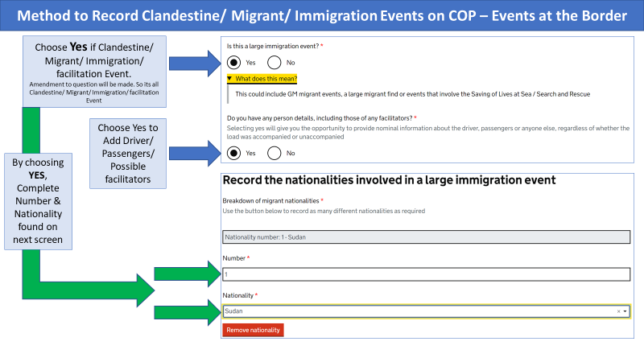

Please ensure relevant detection details are recorded, what detection technology was used, what search technique (offload, full exam etc) and location of clandestines including all vehicle/ trailer registrations/ model/ trailer types.

Any Photos taken, proformas to indicate the location of the Clandestines can be uploaded to the form.

Record Concealment (Empty or Goods Contained within a concealmnt) Detections

Please see below graphic which denotes how to record Concealments/ Empty or Goods contained within. This includes method to show when a concealment detected/ removed and restored.

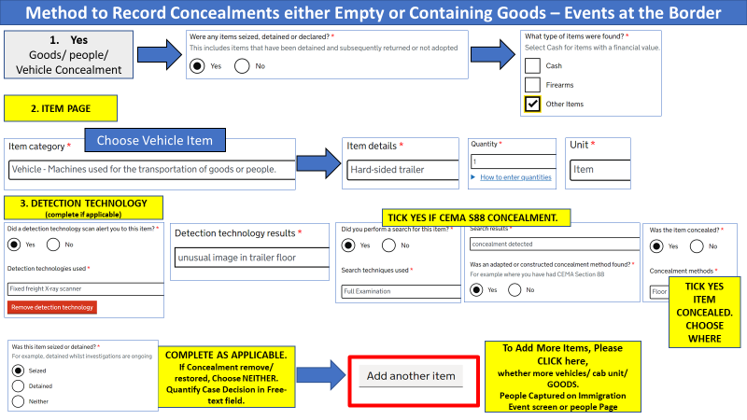

Record Immigration Case Events

Please see below graphic which denotes how to record Immigration Case Events including Document Abuse/ Identity Crime/ IDA etc.

In the event that you have found clandestines or undocumented, user can use the Immigration Event (page 19) to record No/ Nationality and method of concealment.

In the event that you have suspected Immigration rules abuse/ Identity Crime etc and documents are involved, please see below Graphic:

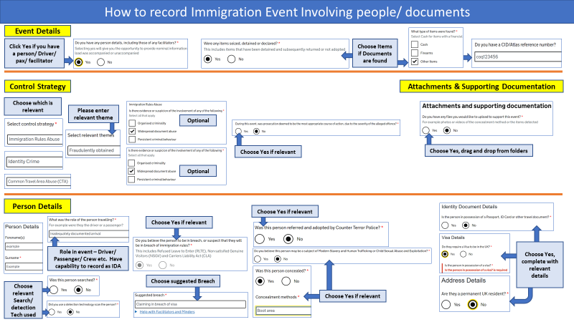

Record Cash Events inc National Security Cash

Please see below Graphic which denotes how to record cash detection, whether Cash is seized/ detained or neither.

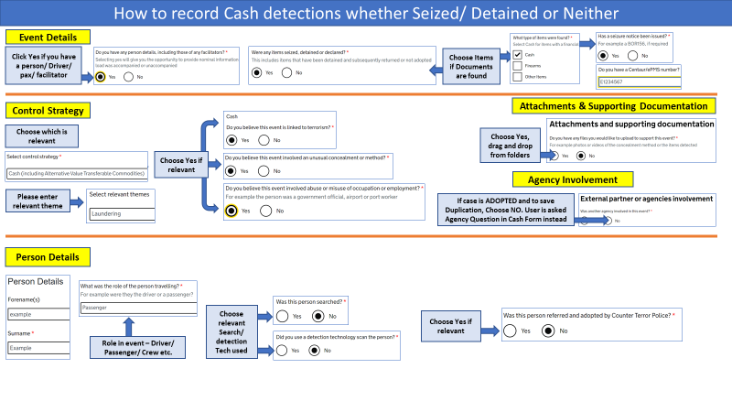

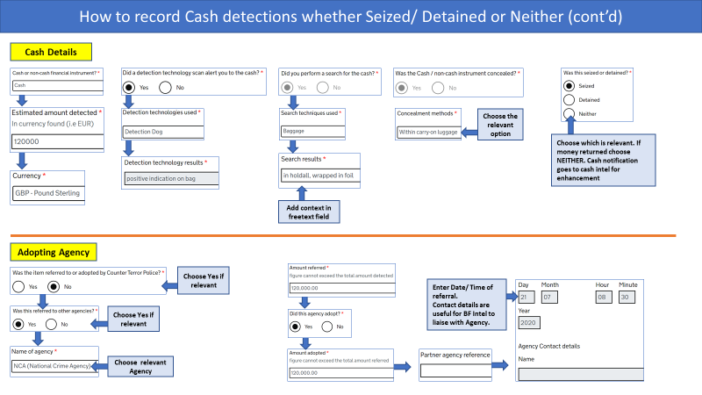

Record National Security Referral - Person/ Items

Please see below graphic which denotes how to record a National Security Referral of a Person and Items, how to record your Outcome Task in both circumstances.

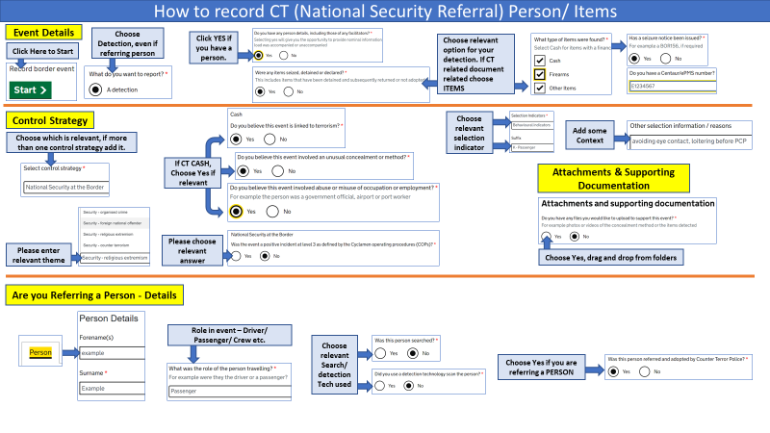

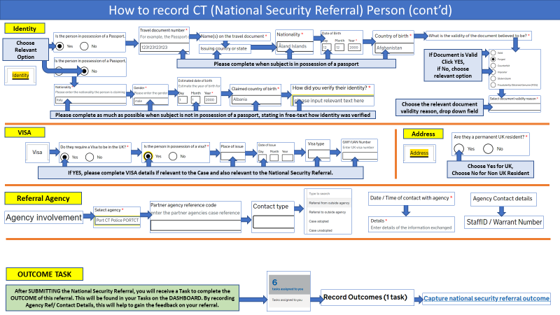

Record National Security Referral - Person/ Items (continued)

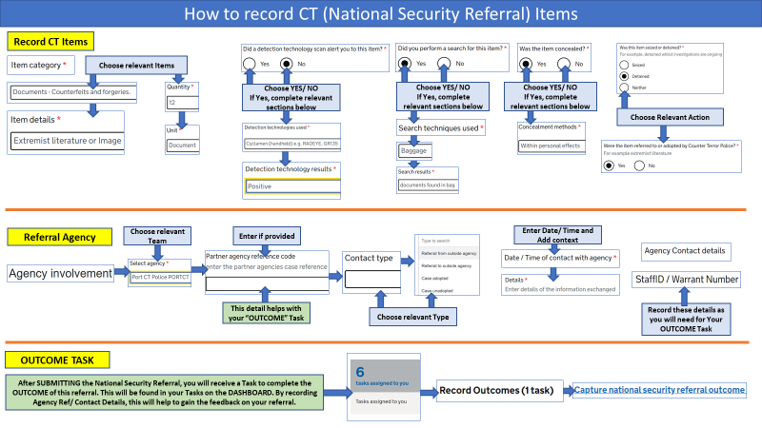

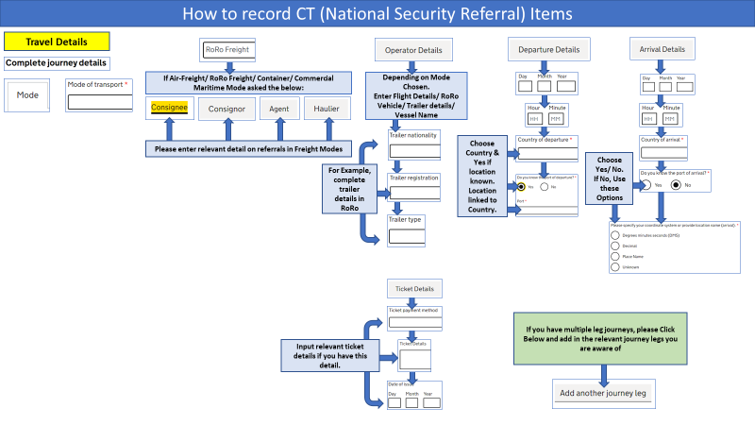

Record SAMS Referral – Person

Please see below graphic which denotes how to record a SAMS (Safeguarding & Modern Slavery Case.)

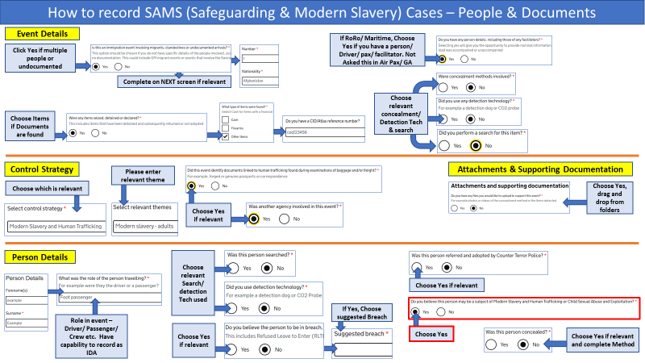

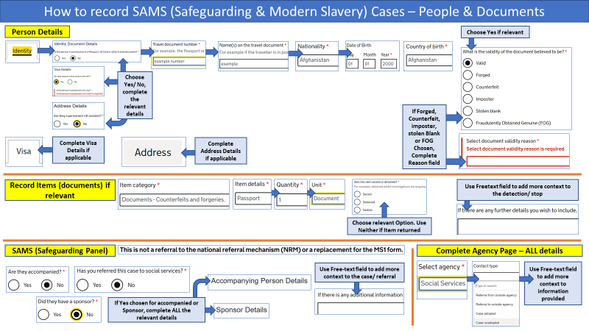

How to Upload Photos/ Documents/ Images to an Event at the Border Form.

The below graphic demonstrates the process to upload images. Work is ongoing so Users will be able to take photo direct from their Work phone camera or obtain the image from within their camera roll. As of 28th July 2020, the only option to upload is from your shared or personal folders on POISE.

If you have taken any photos with your phone, you will need to email them to yourself and save to a specific file. You will need to know the pathway to locate this folder in order to upload by browse or drag and drop options.

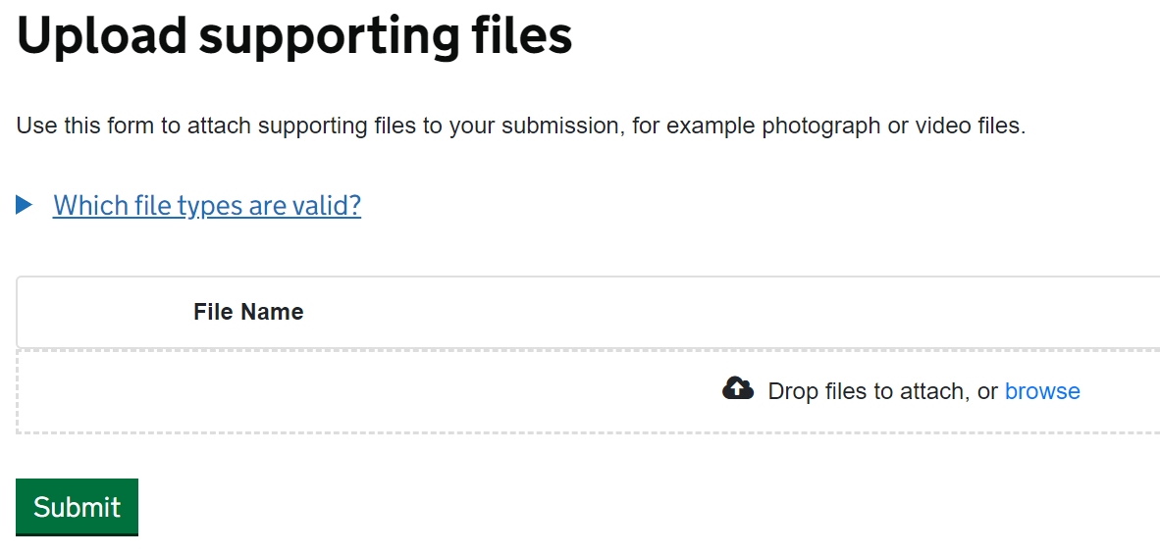

 

Open File location, click on the file, drag and drop into the file box in Events at the Border form.

Alternatively, click **BROWSE**. Locate folder and file, click **Open**.

Once uploaded, file will be named in a list below the Upload box (see below). Upload as many documents as necessary. (see different file types allowed, below)

